CSIS284 Software Analysis & Design

**Final Report**

Project Title

Joe Kanaan & Kinda Alawa

FALL 2023

December 11, 2023

Contents

CSIS284 Software Analysis & Design 1

1

1. Acknowledgement 3

2. Abstract 4

3. Project Background 5

Definition: 5

Scenario: 5

Administrators: 5

4. Project Planning 6

4.1 System Proposal 6

4.2 Feasibility Study 7

5. Analysis 10

5.1 Stakeholders 10

5.2. Requirements 11

5.3 Context Diagram 13

5.4 Activity Diagram 14

6. Software Design 15

6.1 System Architecture 15

6.2. Interfaces 16

6.3 Data Design 17

6.4 Reusability 21

6.5 Risk & Mitigation Plan 23

6.6 Testing Plan 23

7. References 25

# 1. Acknowledgement

I would like to express my deepest gratitude to Dr Antoine Melki, whose expertise and knowledge have been invaluable throughout this course. His continuous support and encouragement have been a source of inspiration and have significantly contributed to the successful completion of CSIS284, Software Analysis.

# 2. Abstract

HammelWmshi is a project used in CSIS284 as a sample. It has a proposal, a feasibility study, under analysis it describes the stakeholders, requirements, Context Diagram, Use Case Scenarios and Activity Diagram. In the Software Design section, it describes System Architecture, Interfaces, Data Design, Reusability, Risks & Mitigation, and Testing Planning. It closes with references.

# 3. Project Background

## Definition:

* HammelWmshi is a company that offers local transportation services.
* Can run on a dedicated machine, website, or app.
* The system is expected to run 24/7
* A possibility of storing user information safely and privately should be offered with notification.

## Scenario:

1. Process Start

* A menu to display package form is activated.
* A message to the user to input package details and destination is displayed.

1. Package Detailed Added:

* Time and cost for delivery is displayed.
* User is asked to confirm.

1. Confirmed:

* User is requested to input debit or credit credentials.

1. Card’s Validity checked:

* If valid, user is asked to confirm.

1. Transaction completed and validated:

* Package delivery starts.
* Card account is charged.

## Administrators:

1. The package delivery system is overseen by the Logistics and Operations Director of HammelWmshi.
2. The system handles daily sales of more than 10 thousand deliveries daily, with financial transactions involving service charges for package deliveries, additional distance charges, and vehicle maintenance costs amounting to more than 25 thousand dollars.
3. With the integration of the new system, an increase in analytical data is anticipated. This data will provide insights into delivery times, vehicle utilization, client demand patterns, and operational efficiency.
4. HammelWmshi's software unit, staffed with competent professionals with an acceptable level of expertise, is responsible for developing, implementing, and maintaining the delivery system software.
5. The head of the software unit is supportive of the new system implementation as there are no other large-scale projects in the immediate pipeline.

# 4. Project Planning

## 4.1 System Proposal

* Project: Online Delivery System (HammelWmshi)
* Project Sponsor: Logistics and Operations Director
* Business Need:
  + The existing delivery systems require manual work, and this leads to slow processing and customer dissatisfaction.
  + HammelWmshi should provide a reliable and automated means of delivering products to businesses.
  + The large number of cell phones make it easier for any employee at a business to use this system.
  + HammelWmshi finds the best vehicle for the delivery which reduces cost for customers.
  + This system will not have any human error and will not cause missed delivery for products.
* Business Requirements:
  + To develop a software system to manage product delivery automatically.
  + The system allows the customer to send products from wherever they are.
  + HammelWmshi finds the optimal vehicle for each delivery according to product weight and vehicle GPS location.
  + This automated system handles payments and sales online, storing the data of each sale.
  + The software gives staff access to the stored information to manage and maintain sales records.
  + The software should notify the driver about the delivery request.
  + This system should notify the client when the product is delivered.
* Business Value:
  + This system should attract ecommerce and other businesses that have lots of products that require delivery.
  + HammelWmshi will have an advantage over competitors that are still using a manual delivery system.
  + This system will reduce delivery time and increase sales by finding the best routes for delivery and avoiding traffic.
  + This system will over time become better at finding types of products delivered and will optimize the vehicle type to reduce cost.
* Special Issues or Constraints
  + This system should be user-friendly with a smooth interface so the employees can easily use the application.
  + Payment procedures must be of the highest standards to ensure that user payment information is safe.
  + Employees should be able to use their accounts on multiple devices.
  + The system should be running on holidays and weekends.

## 4.2 Feasibility Study

**Assumption**: The development team is the project managers and employees.

* **Composition**:
  + Project Managers: System Analysts
  + Employees: Database designers, mobile developers, web developers, security professionals, and IT experts, sales, and marketing team.
* **Salaries**: fixed rate of $35/hr for System Analyst, $25/hr for software designers, $22/hr for mobile and web developers, $25/hr for security professionals, $20/hr for IT experts, $15/hr for sales and marketing team.

**Technical Feasibility:** Can we build it?

* Users’ and analysts’ familiarity with this business application:
  + Application requires database, software design, mobile, and web application skills: High Familiarity.
* Familiarity with Technology:
  + Technology needed: Database, software design, development environment, mobile and web app development: High Familiarity.
* Project Size: Number of people, time, money, and features
  + Number of people: 2 analysts, 2 database designers, 3 software designers, >5 mobile and web developers, 2 security professionals, 4 IT experts, >10 sales and marketing specialists: Good.
* Compatibility with existing systems:
  + The system will need to read different databases: achieved through ODBC’s.
  + HammelWmshi will run on the internet on a website: feasible.
  + The app will be available on mobile devices, on android and IOS: Feasible by the mobile development team.
* Conclusion: Low Technical Risk.

**Economic Feasibility:** Should We build it?

* Identify costs and benefits: tangible and intangible.
  + Tangible costs: Time, salaries for development team, sales team, and managers. Cost for running and maintaining the software, costs for ads.
  + Tangible benefit: Income
  + Intangible Costs: Employees quitting.
  + Intangible benefit:
    - Good brand name leading to more people using it.
    - Better services which increase customer satisfaction.
* Assign values to costs and benefits:
  + Cost of analysis: 2 System analysts will work 80 hours to get the analysis of the system. The cost is 80*2*35/hr = $5600.
  + Cost of design: 3 Software designers will work 100 hours to get the design of the software and its features. The cost is 100*3*25 = $7,500.
  + Cost of development: 8 mobile developers and 9 web developers will work 300 hours to develop the software. The cost is 300*(8+9) *22 = $112,200.
  + Cost of Production: 4 IT experts, 2 security professionals, 12 sales and marketing specialists per month, roughly a month contains 240 working hours. The cost is: 4*20*240 + 2*25*240 + 12*15*240 = $19,200 + $12,000 + $43,200 = $74,000 per month in production.
  + Additional Costs: Cost for advertising, cost for maintenance.
  + Intangible cost: Negative ROI on advertisement.
  + Intangible benefit: Increased referrals from customers due to superior services compared to competitors.
* Determine Cash Flow:
  + Releasing the salaries based on worked hours and job type for each employee at the end of each phase” analysis and design, development, product delivery: Low Risk.
* Access financial viability: Net present value, Return on investment, Breakeven point.
  + NPV: Cash inflow will be higher than cash outflows at the beginning, leading to negative NPV at the start which overtime will become NPV positive. (Some employees will only be working at later stages, example marketing team).
  + ROI: When the service is in production and is being used ROI will be positive.
  + BP: 3-12 months after the system has been launched.
* Conclusion: Moderate Economic Risk

**Organizational Feasibility:** If we build it, will they come?

* Strategic alignment: How well do the project goals align with business objectives?
  + Project uses latest technologies -> increases sales because it will overshadow competitors.
  + Project available 24/7 on machines and mobile -> increases users’ satisfaction: perfect fit to business strategy.
* Stakeholder analysis: full support
* Project champion(s): System Analysts, Development team, sales, and marketing team.
* Organizational management: full support.
* System users: High expectancy
* Conclusion: Low organizational risk.

**Final feasibility assessment:**

* Technical low risk
* Moderate Economic risk
* Organizational low risk
* CONCLUSION: Project is feasible.

# 5. Analysis

## 5.1 Stakeholders

There are 5 main stakeholders for this system:

Businesses:

* Main Role: Businesses are the primary clients and recipients of the delivery service. They rely on the system to efficiently deliver packages to their locations.
* Responsibilities:
  + Providing accurate delivery information, such as addresses and package details.
  + Ensuring timely payment for the delivery services.
  + Coordinating with the system to schedule deliveries.
  + Providing feedback on the quality and efficiency of deliveries.
* Task Goals:
  + Receive packages in a timely and secure manner.
  + Minimize delivery costs.
  + Streamline their own business operations through efficient deliveries.

Vehicle Drivers:

* Main Role: Vehicle drivers are responsible for physically delivering the packages to the businesses.
* Responsibilities:
  + Safely and efficiently transporting packages to their destinations.
  + Verifying package integrity and obtaining necessary signatures or confirmation.
  + Reporting any issues or delays during delivery.
  + Maintaining the vehicle in good working condition.
* Task Goals:
  + Deliver packages on time.
  + Ensure the safety and security of packages during transit.
  + Maintain positive interactions with customers.

(Assumption) Sales Team:

* Main Role: The sales team is responsible for acquiring new business clients and promoting the delivery service.
* Responsibilities:
  + Identifying potential clients and understanding their delivery needs.
  + Pitching the system's capabilities and benefits to potential clients.
  + Negotiating contracts and pricing.
  + Addressing client concerns and feedback.
* Task Goals:
  + Increase the number of business clients using the system.
  + Maximize revenue and profitability for the service.
  + Maintain positive client relationships.

Development Team:

* Main Role: The development team is responsible for building, maintaining, and improving the automated delivery system.
* Responsibilities:
  + Developing and testing software and hardware components.
  + Ensuring system reliability and scalability.
  + Resolving technical issues and implementing updates.
  + Collaborating with other stakeholders to gather feedback for system improvements.
* Task Goals:
  + Create a robust and user-friendly system.
  + Enhance system functionality and performance.
  + Provide technical support and updates as needed.

Administrators:

* Main Role: Administrators oversee the overall management and operation of the delivery system.
* Responsibilities:
  + Setting system policies and rules.
  + Managing user accounts and access.
  + Monitoring system performance and security.
  + Handling any disputes or issues that may arise.
* Task Goals:
  + Maintain system integrity and security.
  + Ensure compliance with regulations and policies.
  + Resolve any conflicts or problems within the system.

## 5.2. Requirements

Functional Requirements:

* User Authentication and Authorization:
  + The system must have secure user authentication and authorization mechanisms for various user roles, including businesses, vehicle drivers, sales team, development team, and administrators.
* Package Management:
  + The system should allow businesses to input package details, including weight, size, destination, and track the package.
  + The system must calculate the optimal vehicle for each delivery based on package weight and distance.
* Scheduling and Routing:
  + The system must schedule deliveries based on business requirements and delivery constraints.
  + It should optimize delivery routes to minimize time and cost.
* Communication and Notifications:
  + The system should support communication between stakeholders, including notifications for package delivery, delays, or issues.
  + Notifications should be sent via email, SMS, or through a mobile app.
* Billing and Payments:
  + Businesses should receive invoices for delivery services.
  + The system must support various payment methods, such as credit cards or invoicing for businesses.
* Feedback and Ratings:
  + Allow businesses to provide feedback and ratings on the quality of deliveries and drivers.
  + Aggregate and display feedback for continuous improvement.

Non-Functional Requirements:

* Performance:
  + The system must handle be able to handle all the businesses who have an account concurrently.
* Scalability:
  + The system should be designed to scale to accommodate a growing user base and increased package delivery demand.
* Reliability:
  + The system should notify the users of downtimes and failures.
  + It should be capable of recovering from system failures.
* Usability:
  + The user interface should be intuitive and user-friendly for all stakeholders.
  + Provide documentation and training for system users and administrators.
* Integration:
  + Integrate mapping and navigation services for route optimization.
  + Provide APIs for potential integration with other business systems.
* Mobile Compatibility:
  + Ensure that the system is accessible and functional on mobile devices for drivers and users who need to track deliveries on the go.

## 5.3 Context Diagram

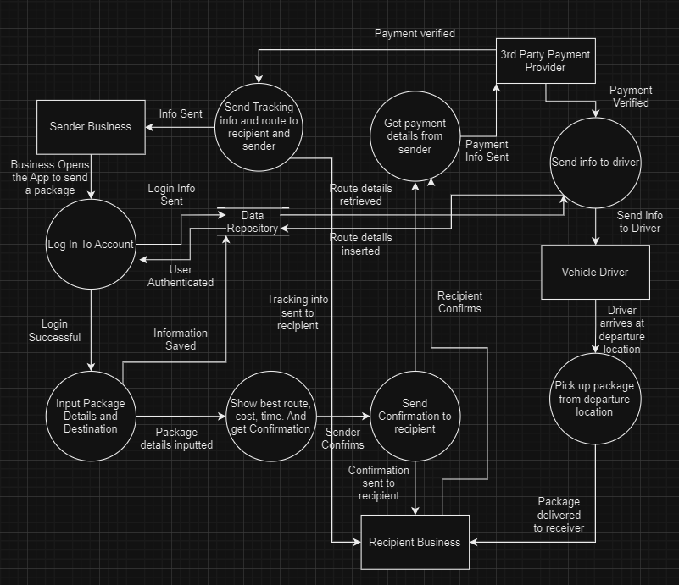

## 5.4 Activity Diagram

# 6. Software Design

## 

## 6.1 System Architecture

Architecture

|  |  |  |
| --- | --- | --- |
| Mobile/Web Interface | Presentation Layer | Authorization: OAuth 2.0, JWT  GUI: Angular |
| Internet | Application Layer | Express.js |
| Database Server  VPN  Linux Server | Persistence Layer | PostgreSQL  NordVPN  Operating System: Linux |

**Hardware Requirements**

|  |  |  |  |  |
| --- | --- | --- | --- | --- |
|  | Processor | RAM | Hard Drive | Remarks |
| Database Server | Multi-Core 64bit x86 | 16 GB | SSD with 1TB space | <https://www.mysql.com/support/> |
| Application Server | Quad-Core 64-bit | 8 GB | 256 GB SSD |  |
| Web Server | 3 GHz CPU | 4 GB | 500 GB |  |

**Tools Specifications**

|  |  |  |
| --- | --- | --- |
| Tool | Description | Reference |
| OAuth 2.0 | A popular framework for user account authorization in applications, known for its efficient handling of access tokens and secure API integration. | <https://oauth.net/2/> |
| Angular | A versatile platform for developing dynamic web applications for both mobile and desktop, featuring a component-based architecture and scalability. | <https://angular.io/> |
| Express.js | A streamlined Node.js web framework, valued for its ease of use and flexibility in building APIs and web applications, while offering essential web features. | <https://expressjs.com/> |
| PostgreSQL | Open source DBMS | <https://www.postgresql.org/> |
| NordVPN | NordVPN is a VPN service that offers secure and private internet access. It protects data transfers with advanced encryption, ensuring that business communications and sensitive information remain confidential. | <https://nordvpn.com/> |
| Linux | Open source unix-like operating system based on the linux kernel | <https://www.linux.org/> |

## 6.2. Interfaces

| Name | Type | Description | Data |
| --- | --- | --- | --- |
| Card Data | Form | Form To: Input the credentials of a debit/credit card | * Card number * Owner Name * Expiry Date * Verification number |
| Card Validation | Form | Form To: Display the card. Input confirmation. | * Validated Card Data |
| Driver Notification | Alert | Alert To: Notify the driver that he must pick up the package. | * Departure location * Package information * Destination location. |
| General Report | PDF File | Tabular report requested by the management describing departure locations, destination locations, package information. Allows filtering. | * Start and end date. * Driver name. * Departure business. * Destination business |
| Login Form | Form | Form To: Get the username and password | * Verification checked using the user table in the database. |
| Package Form | Form | Form To: Get package information using input box. Get destination information. | * Inputted package and destination information. |
| Recipient Notification | Alert | Alert To: Notify that a package will be received at the recipient’s location. | * Package information. * Sender information. |
| Time & Cost Data | Form | Form To: Display the total time needed for package delivery. Display the cost for the delivery. Input a confirmation. | * Calculated time and cost based on driver availability and package information. |

## 6.3 Data Design

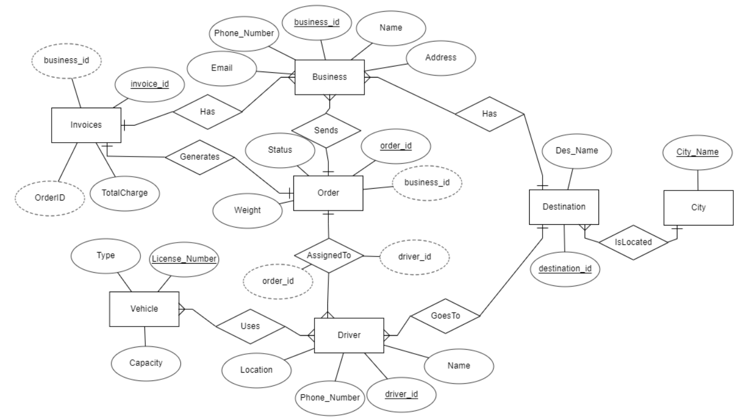

**CRUD Matrix**

| Process | Business | Order | Invoice | Driver | Vehicle | Destination | City |
| --- | --- | --- | --- | --- | --- | --- | --- |
| Add new destination |  |  |  |  |  | C | R |
| Add new order | C | C |  |  |  |  |  |
| Assign driver to order |  | R |  | C |  |  |  |
| Cancel invoice |  |  | D |  |  |  |  |
| Change order driver |  | U |  | U |  |  |  |
| Create invoice | R | R | C |  |  |  |  |
| Create new business account | C |  |  |  |  |  |  |
| Delete business account | D |  |  |  |  |  |  |
| Delete order |  | D |  |  |  |  |  |
| Decommission vehicle |  |  |  |  | D |  |  |
| Register new city |  |  |  |  |  |  | C |
| Register new vehicle |  |  |  |  | C |  |  |
| Remove city from system |  |  |  |  |  |  | D |
| Remove destination |  |  |  |  |  | D |  |
| Remove driver from order |  | U |  | D |  |  |  |
| Track order status |  | R |  | R | R |  |  |
| Update business information | U |  |  |  |  |  |  |
| Update city information |  |  |  |  |  |  | U |
| Update destination details |  |  |  |  |  | U |  |
| Update driver schedule |  |  |  | U |  |  |  |
| Update invoice details |  |  | U |  |  |  |  |
| Update order details |  | U |  |  |  |  |  |
| Update vehicle details |  |  |  |  | U |  |  |
| View invoice records | R | R | R |  |  |  |  |
| View order details | R | R |  |  |  | R | R |

**Data Dictionary**

| Data Field | Type | Description | Primary Key | Foreign Keys |
| --- | --- | --- | --- | --- |
| address | String | Physical address of the business | - | - |
| business_id | Integer | Unique identifier for a business | - | Orders, Invoices |
| capacity | Decimal | Capacity of the vehicle | - | - |
| city_id | Integer | Unique identifier for a city | Cities | Destinations |
| city_name | String | Name of the city | - | Destinations |
| des_name | String | Name of the destination | - | - |
| destination_id | Integer | Unique identifier for a destination | Destination | Orders, Cities |
| driver_id | Integer | Unique identifier for a driver | Driver | Vehicles, Orders |
| email | String | Contact email of the business | - | - |
| invoice_id | Integer | Unique identifier for an invoice | Invoice | Businesses |
| license_number | String | Vehicle license plate number | - | - |
| location | String | Current location of the driver | - | - |
| name | String | Name of the business or driver | - | - |
| order_id | Integer | Unique identifier for an order | Order | Invoices, Destinations |
| phone_number | String | Contact phone number of the business or driver | - | - |
| status | String | Status of the order (e.g., pending, completed) | - | - |
| total_charge | Decimal | Total charge amount for the order | - | - |
| type | String | Type of vehicle (e.g., van, truck) | - | - |
| vehicle_id | Integer | Unique identifier for a vehicle | Vehicle | Drivers |
| weight | Decimal | Weight of the package in the order | - | - |

## 6.4 Reusability

| **COTS** | | | | |
| --- | --- | --- | --- | --- |
| **Component** | **Description** | **Requirements** | **Source** | |
| Routing and Mapping Service | Provides real-time routing for deliveries based on destination. | Real-time GPS tracking and mapping  Optimization for delivery routes | <https://www.mapbox.com/> | |
| Vehicle Management System | Manages the fleet of delivery vehicles and their maintenance. | - Maintenance scheduling  - Integration with delivery system | <https://www.geotab.com/> | |
| Customer Relationship Management (CRM) | Manages interactions with businesses and maintains customer relationships. | - Business account management  - Order and delivery history tracking  - Communication log | <https://www.salesforce.com/> | |
| Secure Payment Processing | Handles invoicing and payment processing securely. | - Secure transaction handling- Invoice generation  - Support for multiple payment methods | <https://stripe.com/> | |
| Inventory Management System | Manages package details, storage, and status. | - Package tracking  - Inventory levels monitoring  - Integration with order processing | <https://www.netsuite.com/> | |
| Notification Service | Sends automatic updates and notifications to businesses and drivers. | - Multi-channel communication (SMS, email)  - Customizable notification triggers | <https://www.twilio.com/> | |
| Document Management System | Handles the storage and management of digital invoices and receipts. | - Secure document storage  - Easy retrieval of invoices  - Compliance with digital recordkeeping | | <https://www.m-files.com/> |
| Reporting and Analytics Tool | Provides business intelligence and analytics for operations. | - Customizable dashboards  - Performance metrics analysis  - Integration with other system components | <https://www.tableau.com> | |
| Components from previous projects | | | | |
| Client Info | Contains all previous info for clients. | Database Server | Library | |
| Driver & Car Info | Contains all previous info for drivers and vehicles | Database Server | Library | |

## 6.5 Risk & Mitigation Plan

| **Risk** | **Mitigation Strategy** |
| --- | --- |
| GPS Disruptions | Utilize a combination of GPS and offline mapping data to ensure routing continues during signal loss. |
| Security Breaches | Invest in robust cybersecurity measures, regular security audits, and employee training on security protocols. |
| Payment Processing Errors | Have backup payment services and manual processing options in place. |
| Data Loss or Corruption | Maintain regular backups and have a disaster recovery plan in place. |
| Inaccurate Delivery Routing | Integrate machine learning for improved route optimization and provide driver feedback mechanisms. |
| Delayed Notifications | Implement a reliable messaging queue and real-time monitoring to ensure timely alerts. |
| Inefficient Inventory Management | Use automated systems for real-time tracking and predictive analytics for inventory levels. |

## 6.6 Testing Plan

| **Test Name** | **Tester** | **Test Type** | **Start Time** | **End Time** | **Comments** |
| --- | --- | --- | --- | --- | --- |
| Order Placement | User/Tester | MS | - | - | Test the end-to-end process of placing a delivery order. |
| Route Optimization | Tester | MIS | - | - | Test the system's ability to find the most efficient routes. |
| Vehicle Assignment | Tester | MS | - | - | Test assigning vehicles to drivers based on order requirements. |
| Driver Notification System | Tester | MS | - | - | Test sending and receiving of notifications to drivers. |
| Payment Processing | Tester | MIS | Outside business hours | - | Test invoice generation and payment transactions. |
| Inventory Tracking | Admin/Tester | MIS | - | - | Test the real-time update of inventory after order processing. |
| Customer Relationship Management | Tester | MISA | - | - | Test the CRM's ability to log and retrieve customer interactions. |
| Performance Testing | Tester | S | Peak hours | - | Test system performance during peak delivery hours. |
| Security Testing | Tester | S | Before system update | - | Test for vulnerabilities and data protection measures. |
| Fleet Management Integration | Tester | MISA | - | - | Test integration with the vehicle management system. |
| Delivery Confirmation | User/Tester | MS | - | - | Test the process of confirming delivery completion. |
| Reporting and Analytics | Tester | MIS | - | - | Test the generation and accuracy of operational reports. |

# 7. References

Hardware Requirements Database server (Dell PowerEdge R940 Rack Server). <https://www.dell.com/en-us/shop/dell-poweredge-servers/poweredge-r940-rack-server/spd/poweredge-r940/pe_r940_12229_vi_vp>

Hardware Requirements Application server (Intel Xeon W-2125 4.0 GHz 4 cores DDR4 256 SSD).

<https://support.hp.com/us-en/document/c05846113#:~:text=Intel%20Xeon%20W,rate%0A%0A120%20W%0A%0ASupports%20Intel%20vPro%20technology>

Hardware Requirements Web server (Intel Xeon E3-1220 V5 processor, 4 x 3.00 GHz CPUs, and options for either a 2 TB HDD or a 500 GB SSD).

<https://www.perfectip.net/dedicated-servers/#:~:text=%23%20Intel%20Xeon%20E3,%2454.99>

Open-source tool OpenAI’s ChatGPT for text generation: <https://chat.openai.com/>

Open-source tool Draw.io for diagrams: <https://app.diagrams.net/>